**Enterprise Resource Planning**

*Of*

**ZAB**

**Training User Manual**

**(SV–12.3.0 | MV–1.0.0)**

**For**

**ASIAN MOTORBIKES LIMITED**

**GENERAL ACCOUNTS**

|  |  |  |
| --- | --- | --- |
| **Option**  **No.** | **Option Name** | **Page No.** |
|  | Account Group | **04** |
|  | Chart of Accounts | **06** |
|  | Chart of Account Serial | **08** |
|  | Financial Year Setting | **09** |
|  | Define Voucher Type | **10** |
|  | GL Voucher Entry | **11** |
|  | Voucher Post / Unpost | **13** |
|  | Voucher Posting By Month | **15** |
|  | Voucher UnPosting By Month | **15** |
|  | Voucher Posting By Date | **16** |
|  | Voucher UnPosting By Date | **16** |
|  | Financial Year Closing | **17** |
|  | Reports | **18** |

# GENERAL ACCOUNTS

**Options >>**

* **[Master](javascript:run1()&menuname=acmst)**

1. **Account Group**
2. **Define Voucher Type**
3. **Voucher Posting**
   1. **Voucher Posting By Month**
   2. **Voucher UnPosting By Month**
   3. **Voucher Posting By Date**
   4. **Voucher UnPosting By Date**
4. **Chart of Accounts**
5. **Financial Year Closing**
6. **Financial Year Setting**
7. **Chart of Account Serial**

* **GL Voucher Entry**
* **Voucher Post / Unpost**

# Account Group

|  |  |  |
| --- | --- | --- |
| **Step 1** |  | Open System **>** Financial Accounts > General Accounts > Master > **Account Group** |
| **Step 2** |  | Write Level 1 Group No. , Description & Account Type |
| **Step 3** |  | Click **Add** |
| **Result** |  | New Account Group Number will be created |

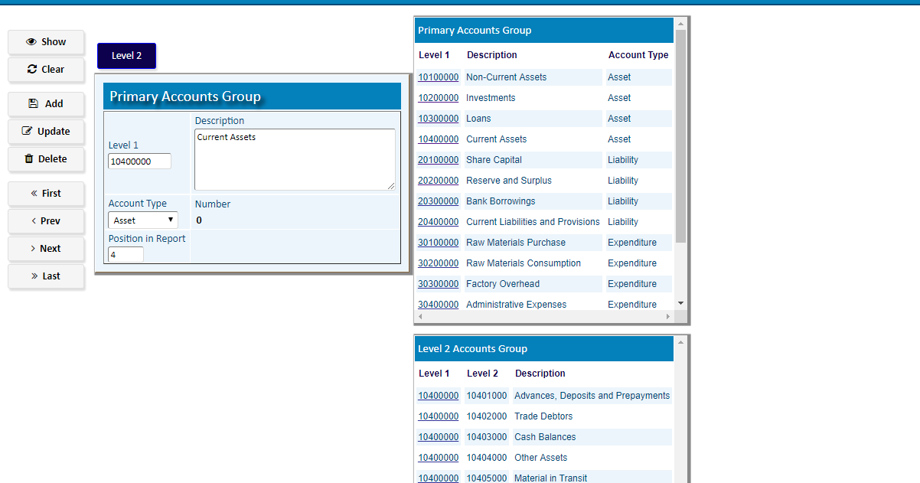

To add second level Account Click **Level 2**

Write Level 2 Account No. , Description & then click **Add**

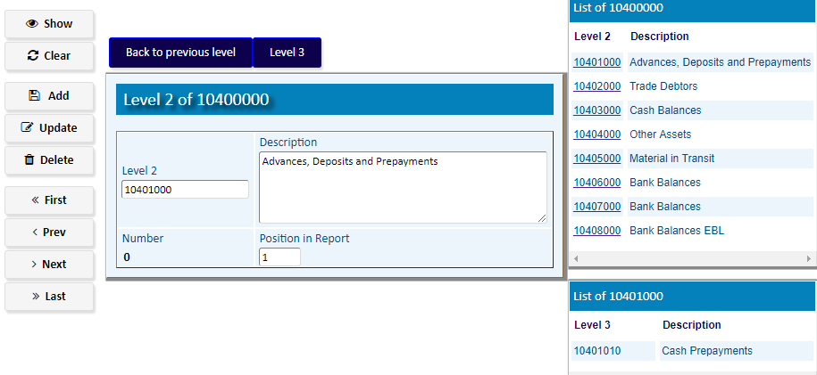

To add Third level Account Click **Level 3**

After Adding All numbers of all level, click **Back to previous Level**

# Chart of Account

|  |  |  |
| --- | --- | --- |
| **Step 1** |  | Open System **>** Financial Accounts > General Accounts > Master > **Chart of Account** |
| **Step 2** |  | Write Account Group No. and Ledger/Account Description |
| **Step 3** |  | Click **Add** |
| **Result** |  | New Account for the selected Account Group will be created |

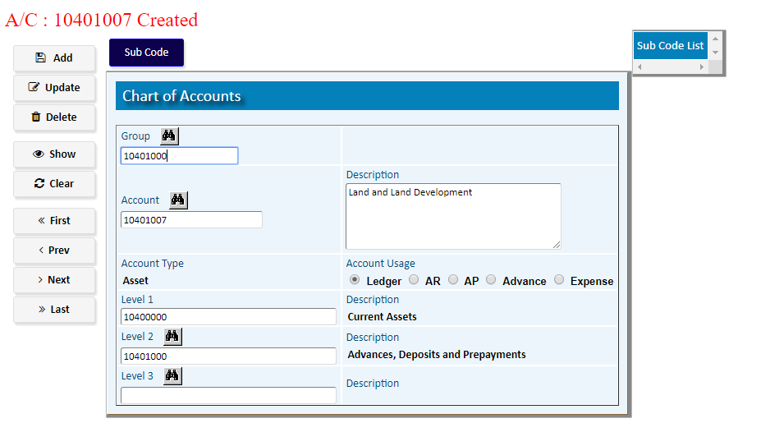

To Add Sub Code, click **Sub Code**

Write Sub Account No. , Description & then click **Add;** A new Sub code of the Account will be Added

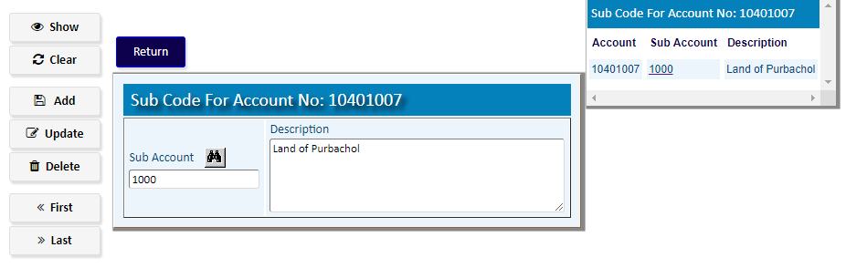

After adding Sub Codes Click **Return**

# Chart of Account Serial

(To manage the serial of Accounts in GL)

|  |  |  |
| --- | --- | --- |
| **Step 1** |  | Open System **>** Financial Accounts > General Accounts> Master > **Chart of Account Serial** |
| **Step 2** |  | Choose the Account Group from the side list & click **Show** |
| **Step 3** |  | Define Number new for GL serial & then Click **Update** |
| **Result** |  | Account group serial will be Updated. |

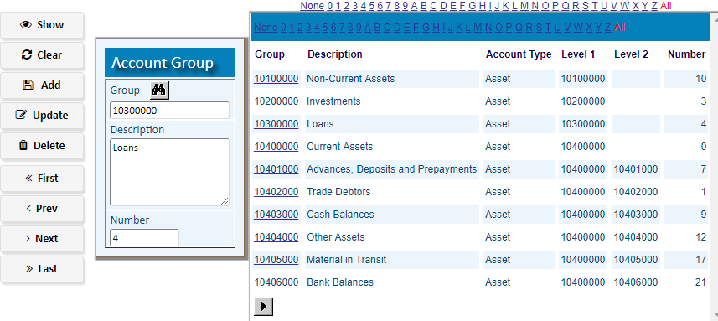

# Financial Year Setting

**(Account default setting)**

|  |  |
| --- | --- |
| **Step 1** | Open System **>** Financial Accounts > General Accounts> Master > **Financial Year Setting** |
| **Step 2** | Click **First**/**Last** |
| **Step 3** | Insert Period Offset |
| **Step 4** | Click **Update** |
| **Alert** | If there is no data - insert Year, Period Offset& thenClick **Add** |
| **Result** | Default Account Setting for the year will be set |

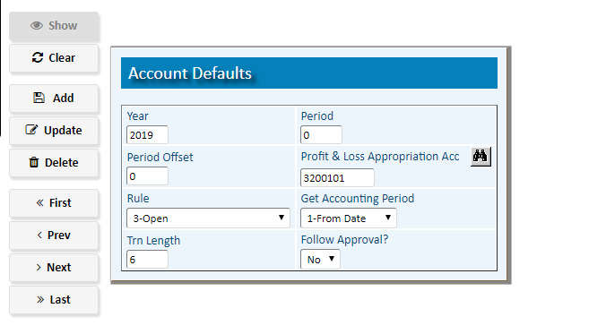

# Define Voucher Type

|  |  |  |
| --- | --- | --- |
| **Step 1** |  | Open System **>** Financial Accounts > General Accounts> Master > **Define Voucher Type** |
| **Step 2** |  | Define Transaction Code, Description |
| **Step 3** |  | Check the Activate of Transaction & Then Click **Add** |
| **Result** |  | New GL voucher transaction code will be created. |

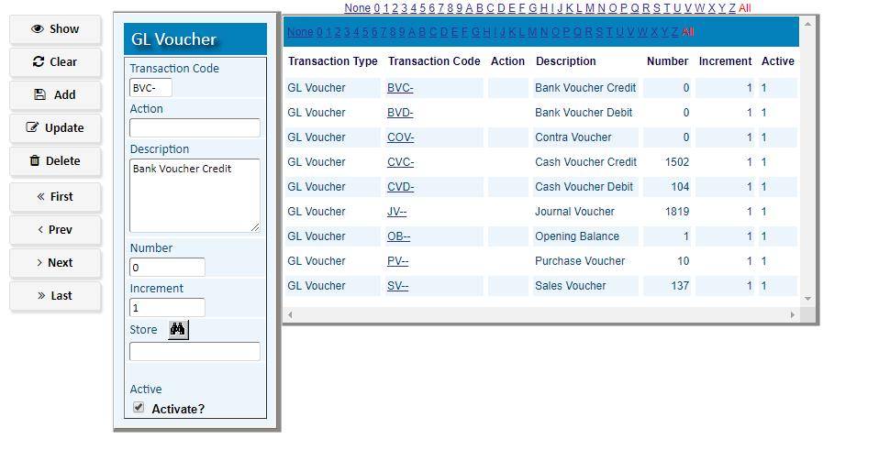

# GL [Voucher Entry](http://192.168.1.17:8080/zab/login?screen=acheader&option=Voucher+Entry&menuname=ac)

[Voucher Entry](http://192.168.1.17:8080/zab/login?screen=acheader&option=Voucher+Entry&menuname=ac) Header

|  |  |
| --- | --- |
| **Step 1** | Open System **>** Financial Accounts > General Accounts > **GL Voucher Entry** |
| **Step 2** | Choose Transaction Code, Write Reference (cheque no.) |
| **Step 3** | Click **Add** |
| **Result** | New Voucher created |

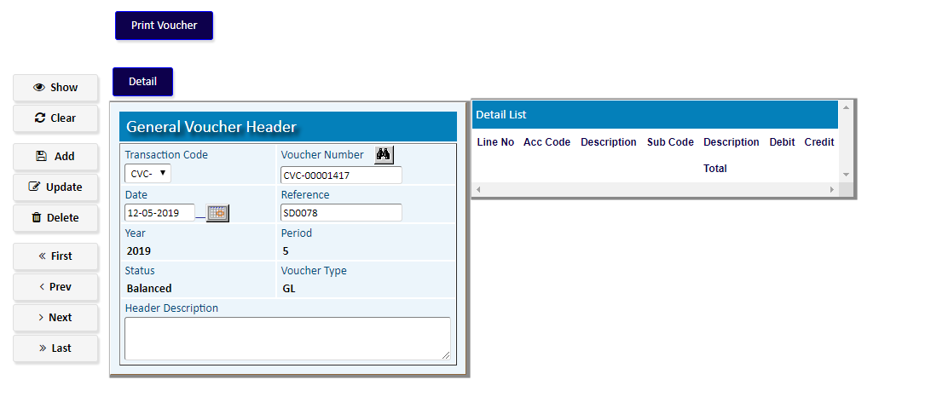

Click **Detail** to add details of the Voucher

[Voucher Entry](http://192.168.1.17:8080/zab/login?screen=acheader&option=Voucher+Entry&menuname=ac) Detail

|  |  |
| --- | --- |
| **Step 1** | Write Debit Account No. , Sub Code (If Applicable) & write Debit Amount & Click **Add** |
| **Step 2** | Write Credit Account No. , Sub Account Code (If Applicable) & write Credit Amount & Click **Add** |
| **Step 3** | Repeat Step 1 to 2 for adding multiple (Debit/Credit account) |
| **Step 4** | Click **Return** to return to Invoice header |
| **Result** | Voucher creation complete |

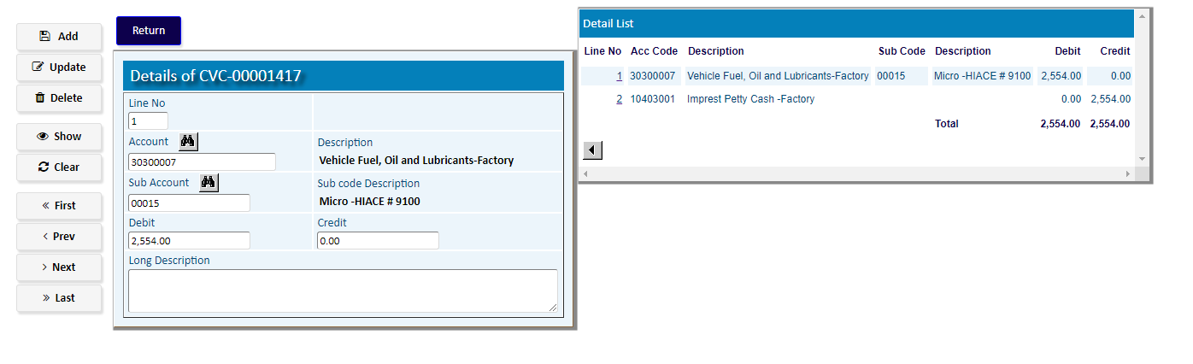

# Voucher Post / Unpost

**For Post**

|  |  |
| --- | --- |
| **Step 1** | Open System **>** Financial Accounts > General Accounts > **Voucher Post / Unpost** |
| **Step 2** | Choose a Voucher Number from side list for Post (or write a Voucher Number & click **Show**) & then Click **Post** |
| **Result** | The Voucher will be posted to the Account Balance |

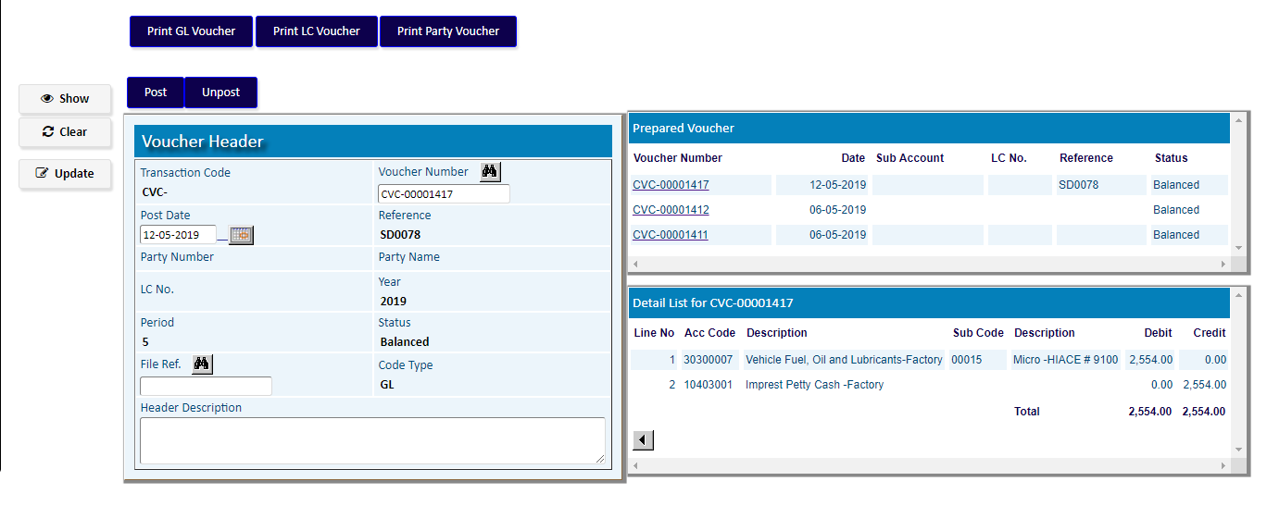

**For Unpost**

|  |  |
| --- | --- |
| **Step 1** | Open System **>** Financial Accounts > General Accounts > **Voucher Post / Unpost** |
| **Step 2** | Write a posted Voucher Number for Unpost, click **Show** & then Click **Unpost** |
| **Result** | The Voucher will be removed from the Account Balance |

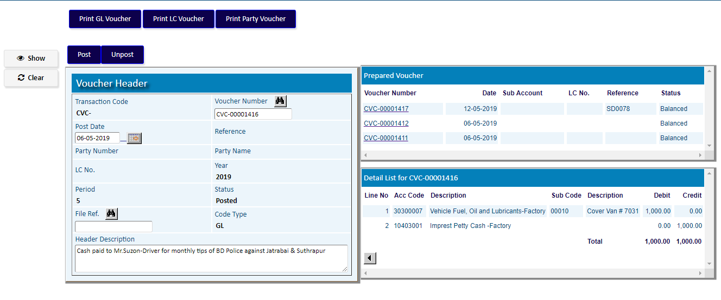

# Voucher Posting By Month

|  |  |
| --- | --- |
| **Step 1** | Open System **>** Financial Accounts > Voucher Posting >  **Voucher Posting By Month** |
| **Step 2** | Choose Year, Per (financial month no.) |
| **Step 3** | Define from trn. (Start Voucher No.) , To Trn. . (End Voucher No.) { for All vouchers, Assign ‘ ‘ to z } |
| **Step 4** | Click **Post** |
| **Result** | The Vouchers of the month will be posted to the Account Balance |

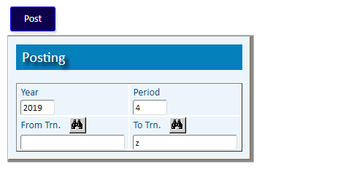

# Voucher UnPosting By Month

|  |  |
| --- | --- |
| **Step 1** | Open System **>** Financial Accounts > Voucher Posting >  **Voucher UnPosting By Month** |
| **Step 2** | Choose Year, Per (financial month no.) |
| **Step 3** | Define from trn. (Start Voucher No.) , To Trn. . (End Voucher No.) { for All vouchers, Assign ‘ ‘ to z } |
| **Step 4** | Click **Unpost** |
| **Result** | The Posted Vouchers of the month will be removed from the Account Balance |

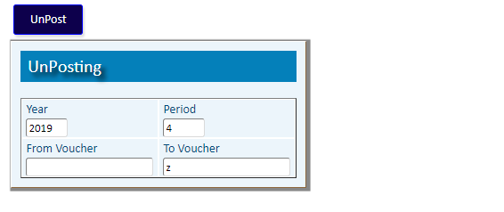

# Voucher Posting By Date

|  |  |
| --- | --- |
| **Step 1** | Open System **>** Financial Accounts > Voucher Posting >  **Voucher Posting By Date** |
| **Step 2** | Choose From Date |
| **Step 4** | Click **Post** |
| **Result** | The Vouchers from the assigned date will be posted to the Account Balance |

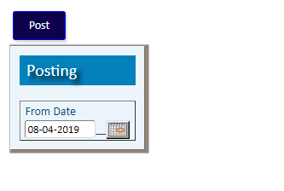

# Voucher UnPosting By Date

|  |  |
| --- | --- |
| **Step 1** | Open System **>** Financial Accounts > Voucher Posting >  **Voucher UnPosting By Date** |
| **Step 2** | Choose From Date |
| **Step 4** | Click **Unpost** |
| **Result** | The Vouchers from the assigned date will be removed from the Account Balance |

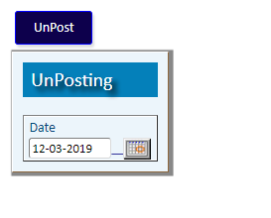

# Financial Year Closing

|  |  |
| --- | --- |
| **Step 1** | Open System **>** Financial Accounts > Master >  **Financial Year Closing** |
| **Step 2** | Write Closing Year |
| **Step 4** | Click **Process** |
| **Result** | Financial Year Closing process will be completed |

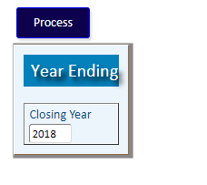

# Reports

|  |  |  |
| --- | --- | --- |
| **Step 1** | | Open System **>** Financial Accounts > **Reports** |
| **Step 2** | | Choose A report Option |
| **Step 4** | | Select required parameters (Date, Acc No., Year etc.) of the report |
| **Step 4** | Click **“View Report”** to preview in print format. | | |
| **Result** | The report is previewed in print format. | | |

